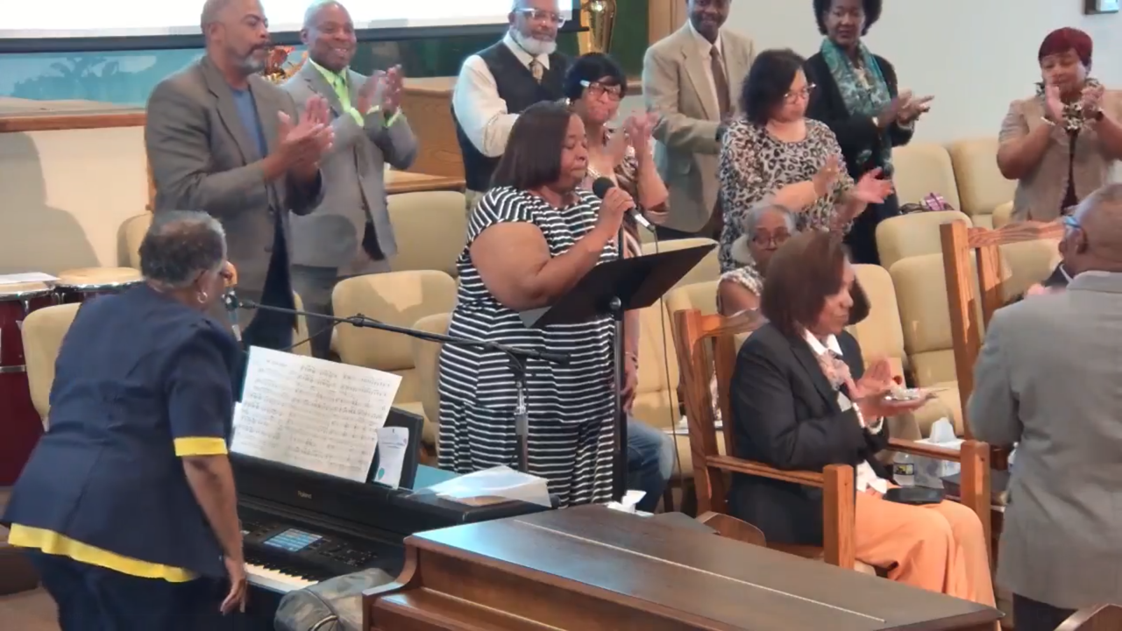

GET IN TOUCH
Have questions? Need more information about our church or an upcoming event? Flease feel free to reach out to us!
Collection services work best for those who’ll be in one location for most of the day, maybe you work from home, or have consignments that need to be collected from the office.


Visit Us
1201 S 8th St
Paducah, KY 42003


Call Us
(270) 443-3714


E-Mail Us
mtmoriahmbc1201@gmail.com


Fax
(270) 443-7125

